Irregular-Region Generator

Definition
# Source: AI Source: Provided by: [Data Path: Persons Table -> ID Column: 1, Name_En Column: Motasem Essam] -> From: [ChatGPT] on [7/25/2026]
An Irregular-Region Generator is a filled, two-dimensional plane region with an irregular or non-standard boundary that can be used to generate a three-dimensional solid through geometric movement or transformation.
Unlike regular regions such as circles, rectangles, and regular polygons, an irregular region does not follow one fixed standard geometric shape. Its boundary may consist of unequal straight segments, curved portions, or a combination of different boundary elements.
When an irregular plane region is moved through space, it can generate different solids depending on the type of movement:
- Translation: moves the region along a straight path, producing an extruded solid.
- Rotation: rotates the region around an axis, producing a solid of revolution.
- General sweeping: moves the region along a curved or spatial path, producing a swept solid.
- Lofting or transition: connects the region to other cross-sectional regions, potentially changing its shape or size.
In geometric modeling, a closed planar region may also contain internal holes, which become holes in the generated solid when swept or extruded.

Geometric Representation
# Source: AI Source: Provided by: [Data Path: Persons Table -> ID Column: 1, Name_En Column: Motasem Essam] -> From: [ChatGPT] on [7/25/2026]
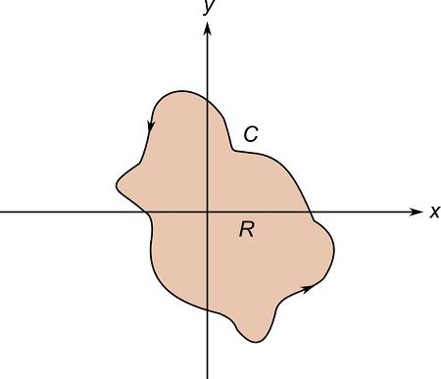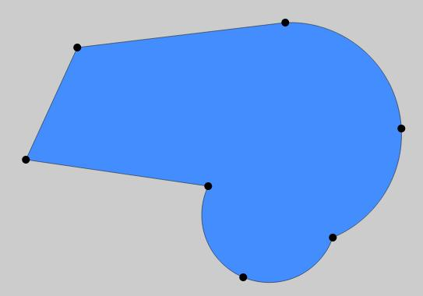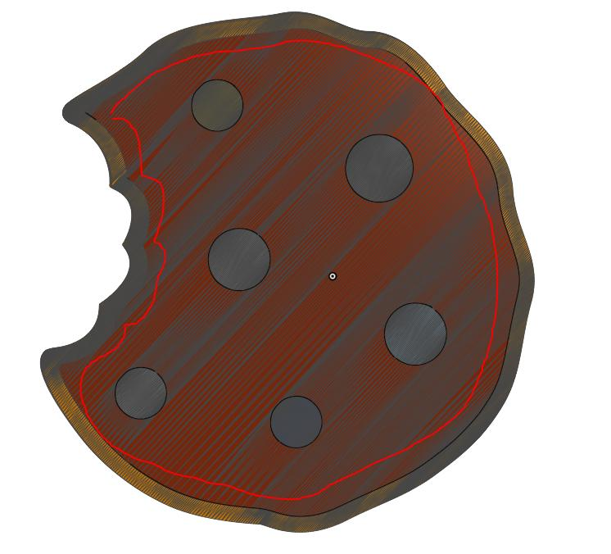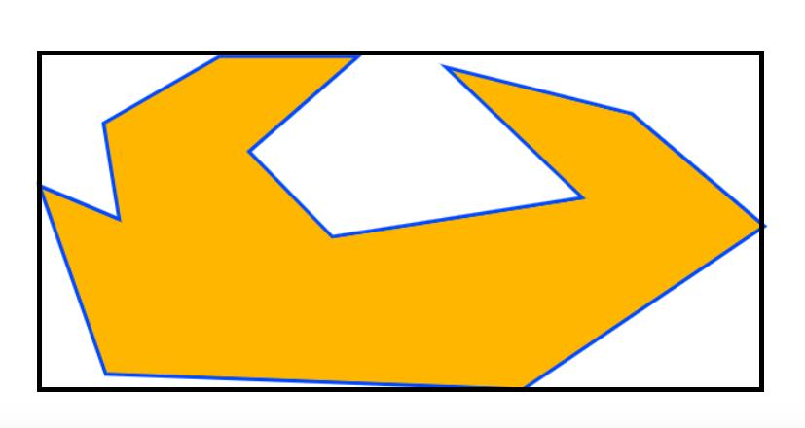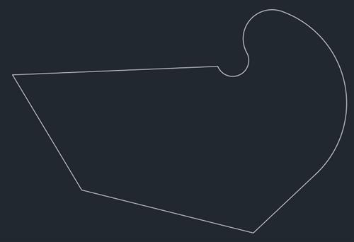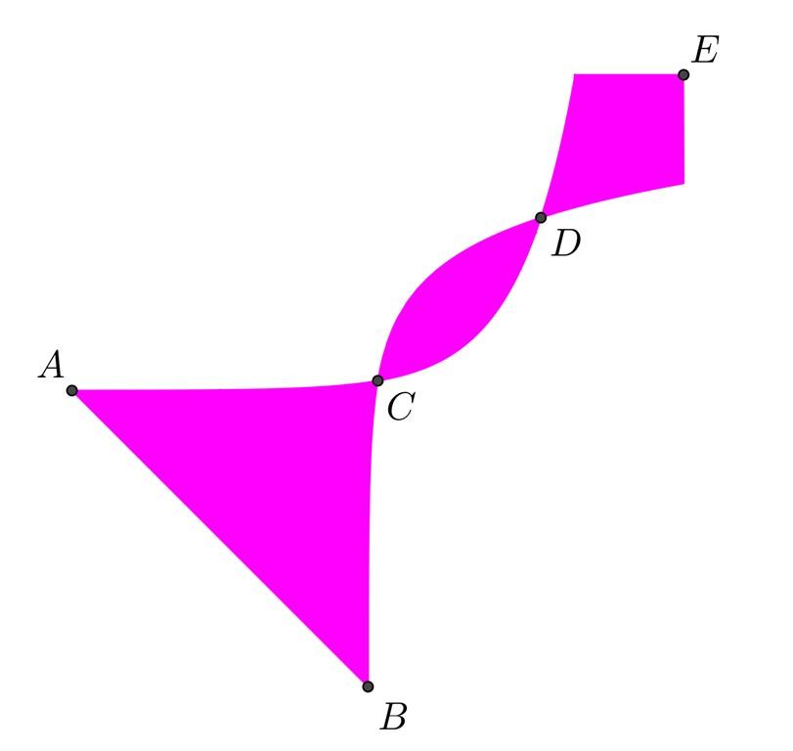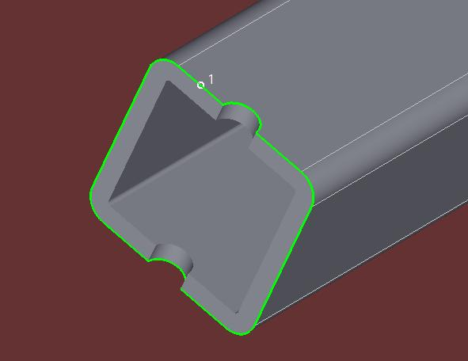
An irregular region is represented as a bounded area enclosed by a closed boundary.
Its boundary may contain:
- Unequal straight-line segments.
- Curved lines and arcs.
- Irregular polygonal edges.
- Mixed straight and curved portions.
- One or more internal boundaries representing holes.
The region must be distinguished from its boundary: the irregular region is the filled area, whereas the irregular boundary is only the outline.

Geometric Structure
# Source: AI Source: Provided by: [Data Path: Persons Table -> ID Column: 1, Name_En Column: Motasem Essam] -> From: [ChatGPT] on [7/25/2026]
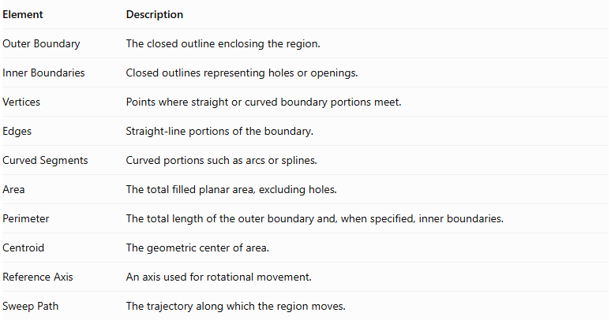
Element | Description
Outer Boundary | The closed outline enclosing the region.
Inner Boundaries | Closed outlines representing holes or openings.
Vertices | Points where straight or curved boundary portions meet.
Edges | Straight-line portions of the boundary.
Curved Segments | Curved portions such as arcs or splines.
Area | The total filled planar area, excluding holes.
Perimeter | The total length of the outer boundary and, when specified, inner boundaries.
Centroid | The geometric center of area.
Reference Axis | An axis used for rotational movement.
Sweep Path | The trajectory along which the region moves.

Classification of Irregular Regions

According to Boundary Composition
# Source: AI Source: Provided by: [Data Path: Persons Table -> ID Column: 1, Name_En Column: Motasem Essam] -> From: [ChatGPT] on [7/25/2026]
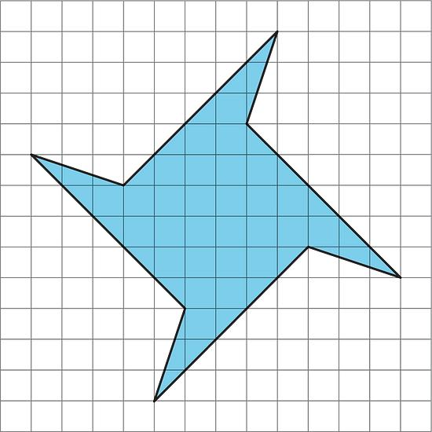
A. Straight-Edged Irregular Region
A filled region enclosed entirely by straight-line segments of unequal lengths or varying angles.
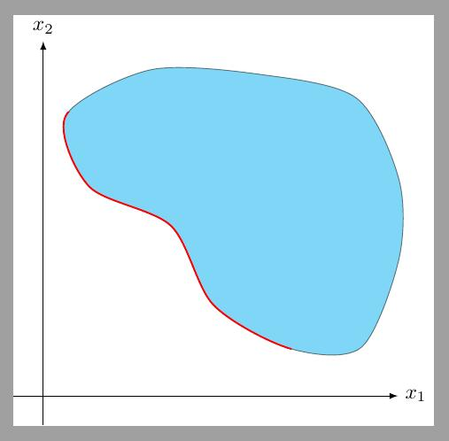
B. Curved-Boundary Irregular Region
A filled region whose boundary contains curved portions, such as arcs or freeform curves.
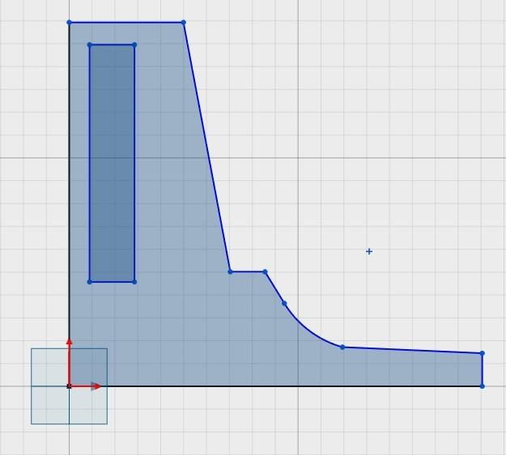
C. Mixed-Boundary Irregular Region
A filled region enclosed by a combination of straight-line and curved boundary portions.

According to Boundary Shape
# Source: AI Source: Provided by: [Data Path: Persons Table -> ID Column: 1, Name_En Column: Motasem Essam] -> From: [ChatGPT] on [7/25/2026]
- Convex Irregular Region: A region in which every line segment joining two points inside the region lies entirely within the region.
- Concave Irregular Region: A region containing at least one indentation, such that some line segment joining two points inside it passes outside the region.
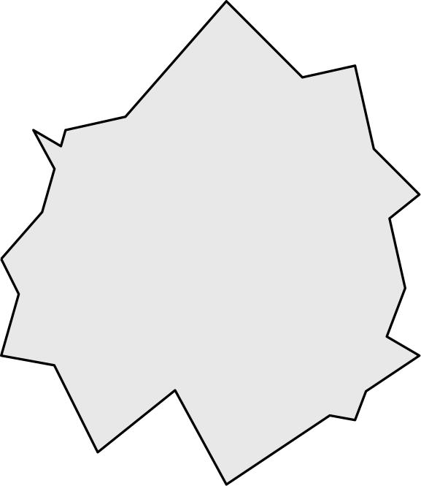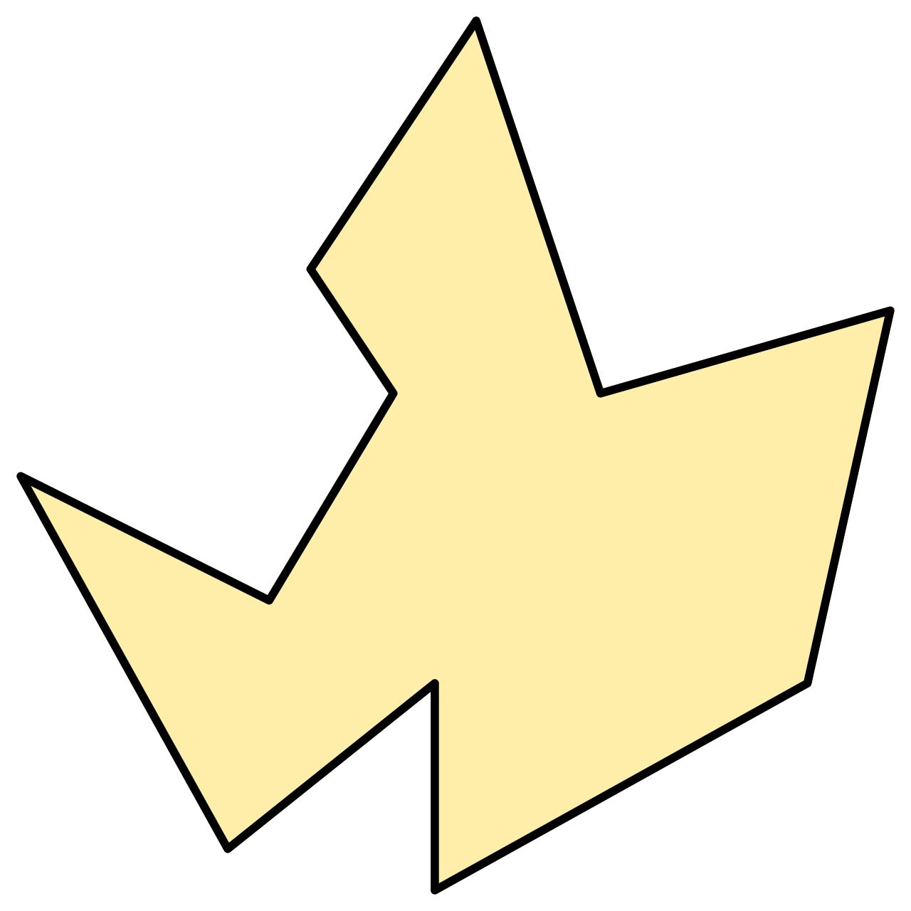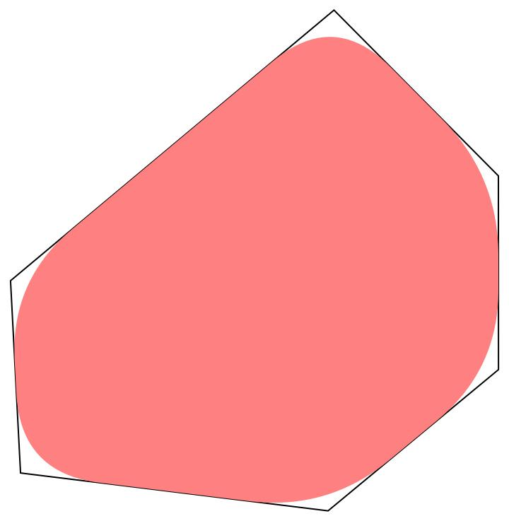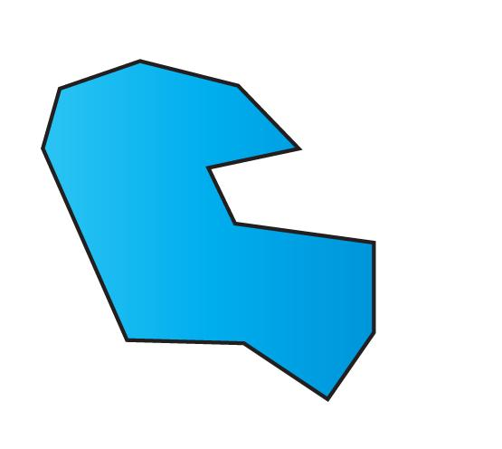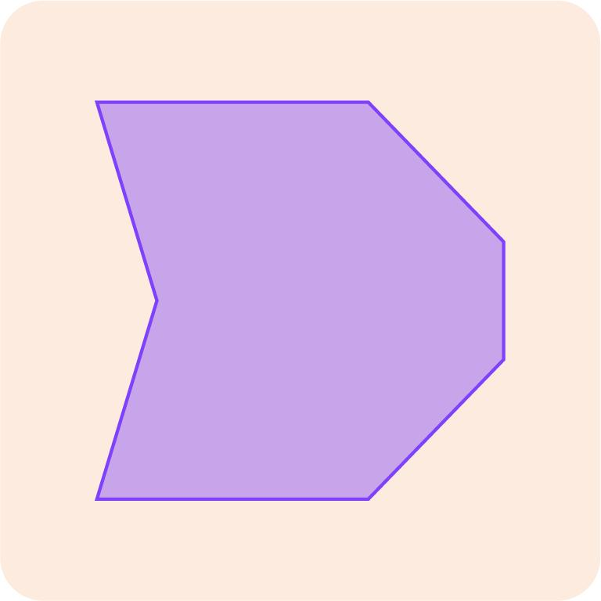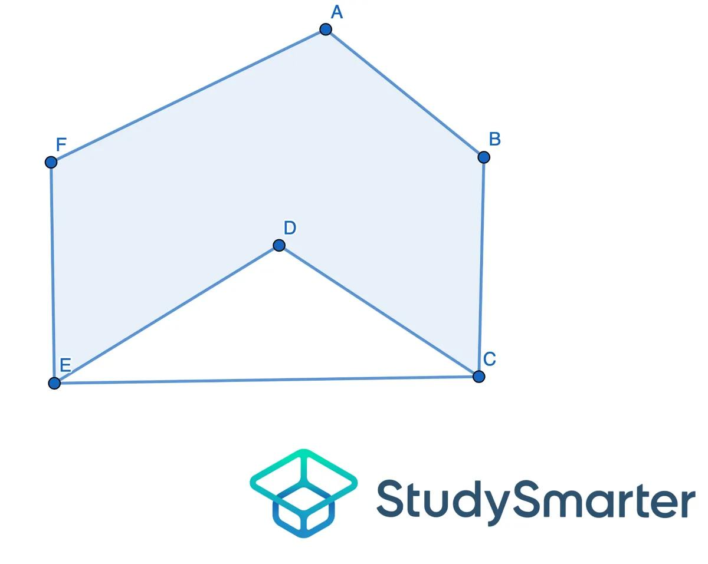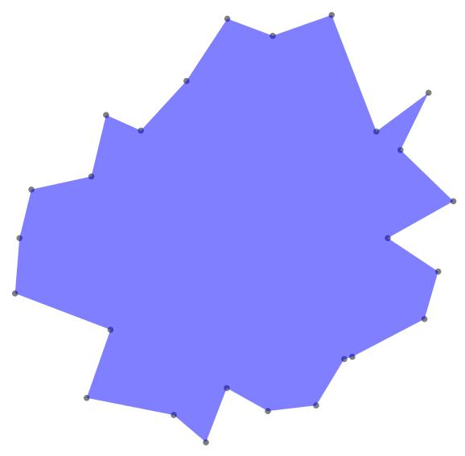

According to Internal Structure
# Source: AI Source: Provided by: [Data Path: Persons Table -> ID Column: 1, Name_En Column: Motasem Essam] -> From: [ChatGPT] on [7/25/2026]
- Simple Irregular Region: A single connected filled region without holes.
- Irregular Region with Holes: A region containing one or more internal openings.
- Composite Irregular Region: A region formed by combining multiple simpler regions with different shapes.
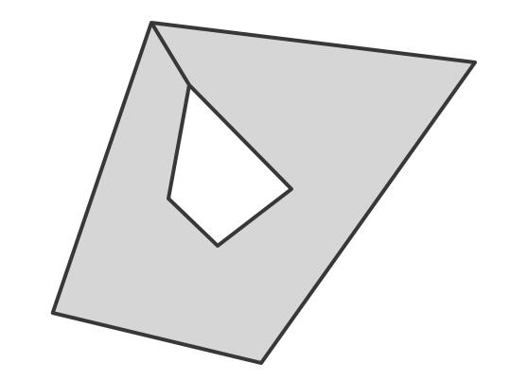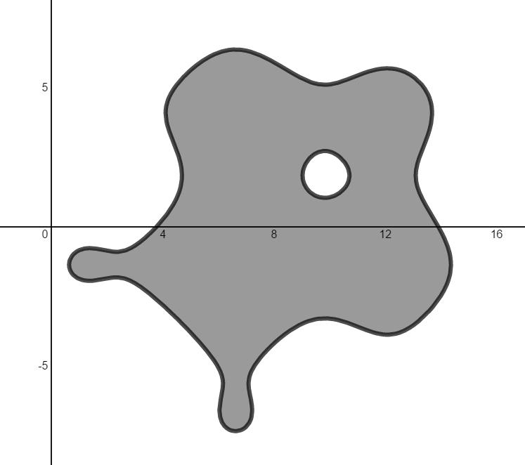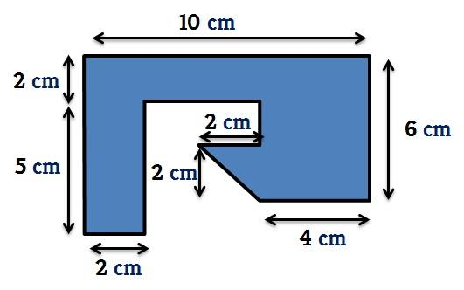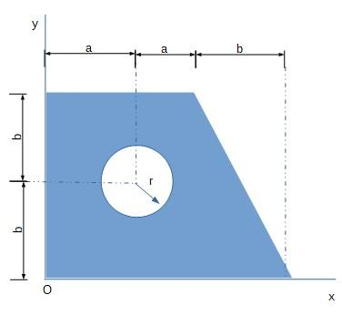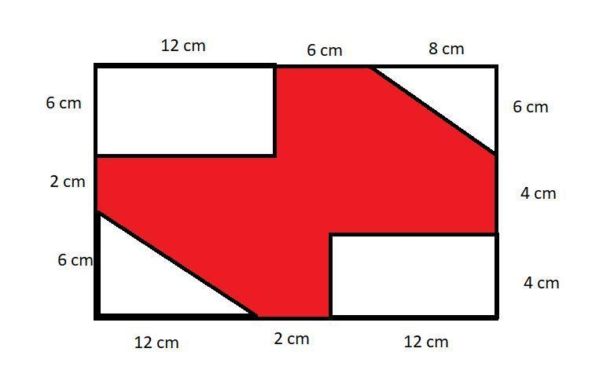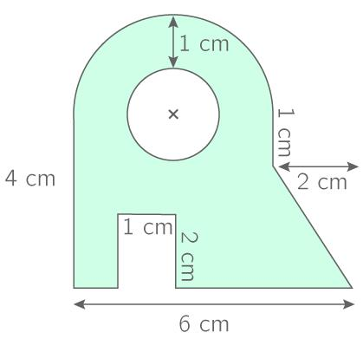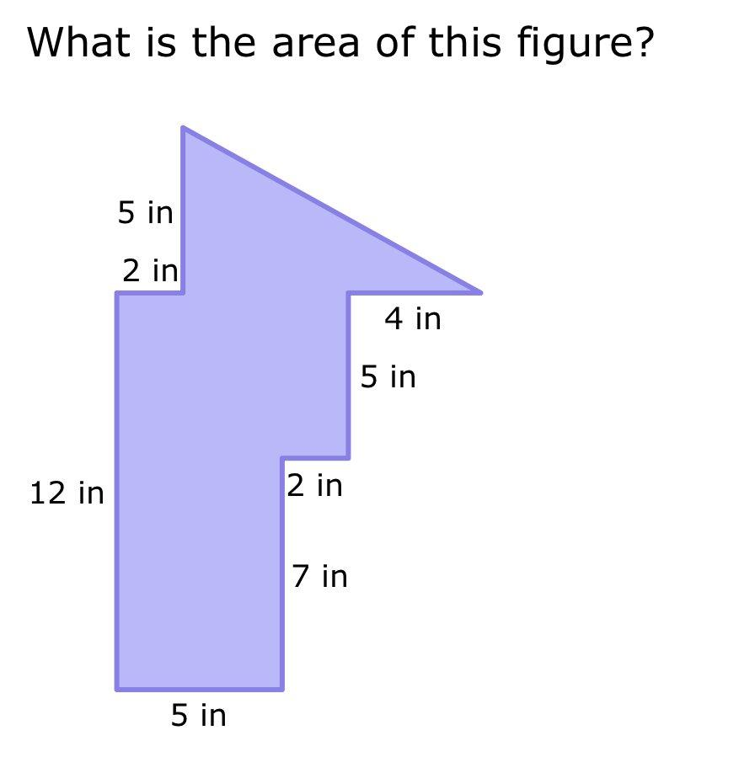

Types of Solids Generated

Translational Generation
# Source: AI Source: Provided by: [Data Path: Persons Table -> ID Column: 1, Name_En Column: Motasem Essam] -> From: [ChatGPT] on [7/25/2026]
When an irregular region is translated along a straight path while maintaining its shape and orientation, it generates an irregular extruded solid.
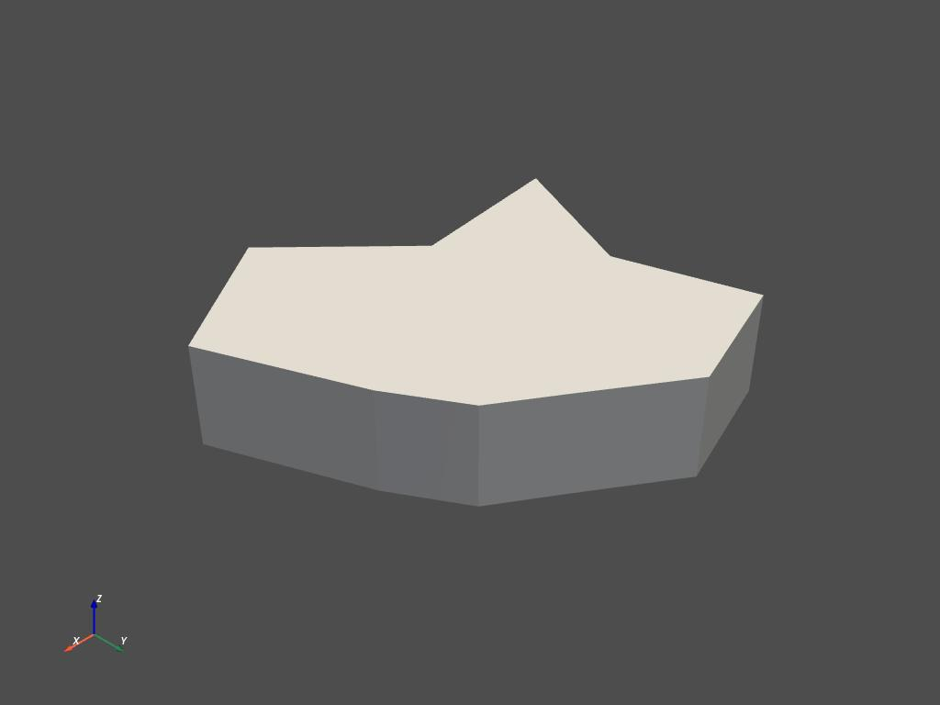
Types include:
- Right Irregular Extruded Solid: The translation direction is perpendicular to the plane of the region.
- Oblique Irregular Extruded Solid: The translation direction is inclined relative to the plane's normal.
- Hollow Irregular Extruded Solid: The generating region contains internal holes that extend through the solid.
For a constant cross-section translated a distance $h$:
$$V=Ah$$
Where:
- $V$ = volume.
- $A$ = area of the irregular generating region.
- $h$ = extrusion length.

Rotational Generation
# Source: AI Source: Provided by: [Data Path: Persons Table -> ID Column: 1, Name_En Column: Motasem Essam] -> From: [ChatGPT] on [7/25/2026]
When an irregular region rotates around an axis in its plane, it generates a solid of revolution. The resulting shape depends on the region's boundary and its position relative to the axis.
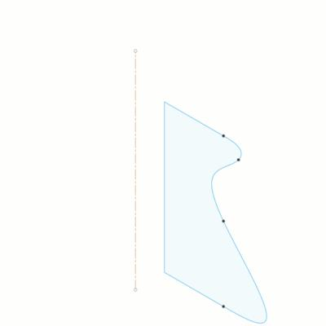
Possible results include:
- Irregular rotational solids.
- Solids with curved and flat surface portions.
- Hollow rotational solids, when the generating region is positioned to create an opening.
- Composite solids of revolution.
The resulting solid is not necessarily a standard cylinder, cone, sphere, or torus.

General Sweeping Generation
# Source: AI Source: Provided by: [Data Path: Persons Table -> ID Column: 1, Name_En Column: Motasem Essam] -> From: [ChatGPT] on [7/25/2026]
When an irregular region moves along a curved or three-dimensional path, it generates a general swept solid.
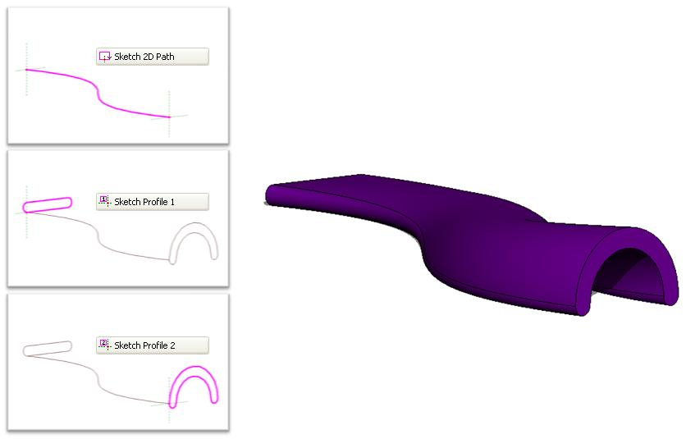
Examples include:
- Curved irregular beams.
- Irregular-section pipes and ducts.
- Curved structural components.
- Custom-profile swept objects.
The cross-section may retain its shape and orientation or undergo controlled changes along the path.

Lofting and Transition Generation
# Source: AI Source: Provided by: [Data Path: Persons Table -> ID Column: 1, Name_En Column: Motasem Essam] -> From: [ChatGPT] on [7/25/2026]
An irregular region can also be connected to one or more other planar cross-sections to produce a transition solid.
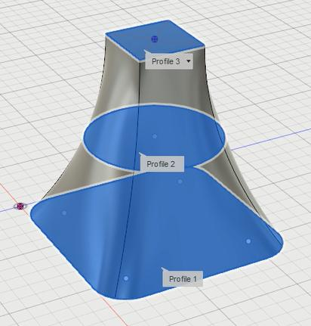
Examples include:
- Irregular-to-irregular transition solids.
- Irregular-to-circular transition solids.
- Variable-cross-section solids.
- Tapered or gradually changing solids.
Unlike a simple extrusion, lofting can change the cross-sectional shape or size along the generated solid.

Mathematical Representation
# Source: AI Source: Provided by: [Data Path: Persons Table -> ID Column: 1, Name_En Column: Motasem Essam] -> From: [ChatGPT] on [7/25/2026]
An irregular region does not have one universal area formula. Its area is calculated according to its boundary representation or by dividing it into simpler geometric regions.

Area Calculation
# Source: AI Source: Provided by: [Data Path: Persons Table -> ID Column: 1, Name_En Column: Motasem Essam] -> From: [ChatGPT] on [7/25/2026]
A. Decomposition Method
Divide the irregular region into simpler shapes, such as triangles, rectangles, circles, and circular sectors.
$$A_{\text{total}}=\sum_{i=1}^{n}{A_{i}}$$
For a region containing holes:
$$A_{\text{region}}=A_{\text{outer}}-\sum_{j=1}^{m}{A_{\text{hole},j}}$$
B. Integration Method
If the region is bounded by curves, its area can be calculated using definite integration.
For a region between two functions:
$$A=\int_{a}^{b}{}|f(x)-g(x)| dx$$
A more general boundary-based area formula is:
$$A=\frac{1}{2}\left|{oint}_{∂R}(x dy-y dx)\right|$$

Volume of an Extruded Irregular Region
# Source: AI Source: Provided by: [Data Path: Persons Table -> ID Column: 1, Name_En Column: Motasem Essam] -> From: [ChatGPT] on [7/25/2026]
For a constant cross-section:
$$\boxed{V=Ah}$$
Where $h$ is the perpendicular distance between the two parallel end planes.
For a right extrusion:
$$V=Ah$$
For an oblique extrusion, $h$ is still the perpendicular separation of the end planes, not the length of the inclined translation path.

Surface Area of a Right Extruded Solid
# Source: AI Source: Provided by: [Data Path: Persons Table -> ID Column: 1, Name_En Column: Motasem Essam] -> From: [ChatGPT] on [7/25/2026]
For a region with an outer perimeter $P_{o}$ and internal-hole perimeters $P_{i}$:
$$A_{\text{lateral}}=h\left(P_{o}+\sum_{i=1}^{m}{P_{i}}\right)$$
The total surface area, when all boundary surfaces are exposed, is:
$$A_{\text{total}}=2A+h\left(P_{o}+\sum_{i=1}^{m}{P_{i}}\right)$$

Volume of a Rotational Solid
# Source: AI Source: Provided by: [Data Path: Persons Table -> ID Column: 1, Name_En Column: Motasem Essam] -> From: [ChatGPT] on [7/25/2026]
For a region rotated around an external coplanar axis that does not intersect the region, Pappus's centroid theorem gives:
$$\boxed{V=2πdA}$$
Where:
- $A$ = area of the generating region.
- $d$ = distance traveled by the region's centroid during one complete revolution.
If the centroid is at perpendicular distance $r_{c}$ from the axis:
$$V=2πr_{c}A$$
This formula requires the axis to lie outside the generating region under the standard application of the theorem. Other rotational configurations can be calculated using integration.

Mathematical Properties
# Source: AI Source: Provided by: [Data Path: Persons Table -> ID Column: 1, Name_En Column: Motasem Essam] -> From: [ChatGPT] on [7/25/2026]
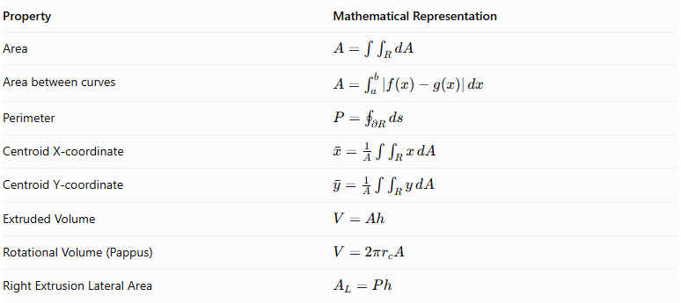
Property | Mathematical Representation
Area | $$A=\int{\int_{R}{dA}}$$
Area between curves | $$(A=\int_{a}^{b}{}$$ | f(x)-g(x) | \,dx\)
Perimeter | $$P={oint}_{∂R}ds$$
Centroid X-coordinate | $$barx=\frac{1}{A}\int{\int_{R}{x}} dA$$
Centroid Y-coordinate | $$bary=\frac{1}{A}\int{\int_{R}{y}} dA$$
Extruded Volume | $$V=Ah$$
Rotational Volume (Pappus) | $$V=2πr_{c}A$$
Right Extrusion Lateral Area | $$A_{L}=Ph$$
For regions with holes, the area and centroid calculations must account for the removed areas.

Applications
# Source: AI Source: Provided by: [Data Path: Persons Table -> ID Column: 1, Name_En Column: Motasem Essam] -> From: [ChatGPT] on [7/25/2026]
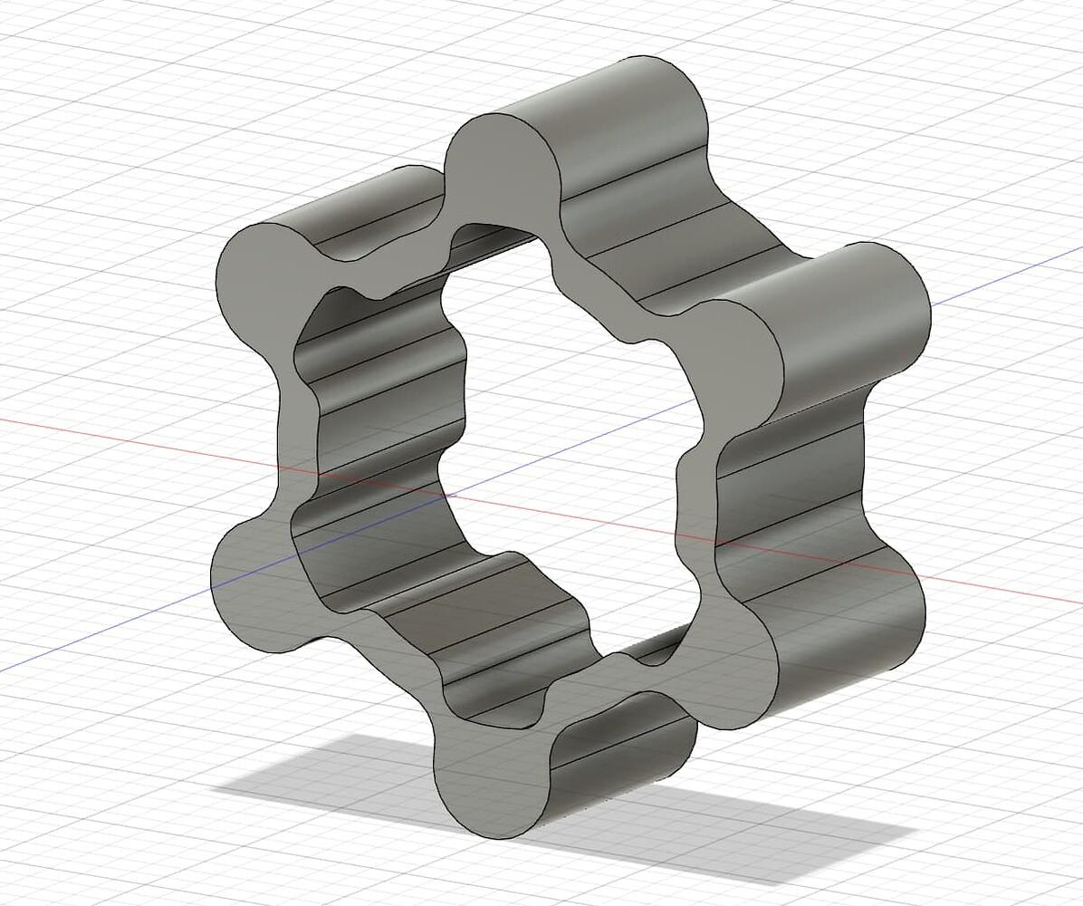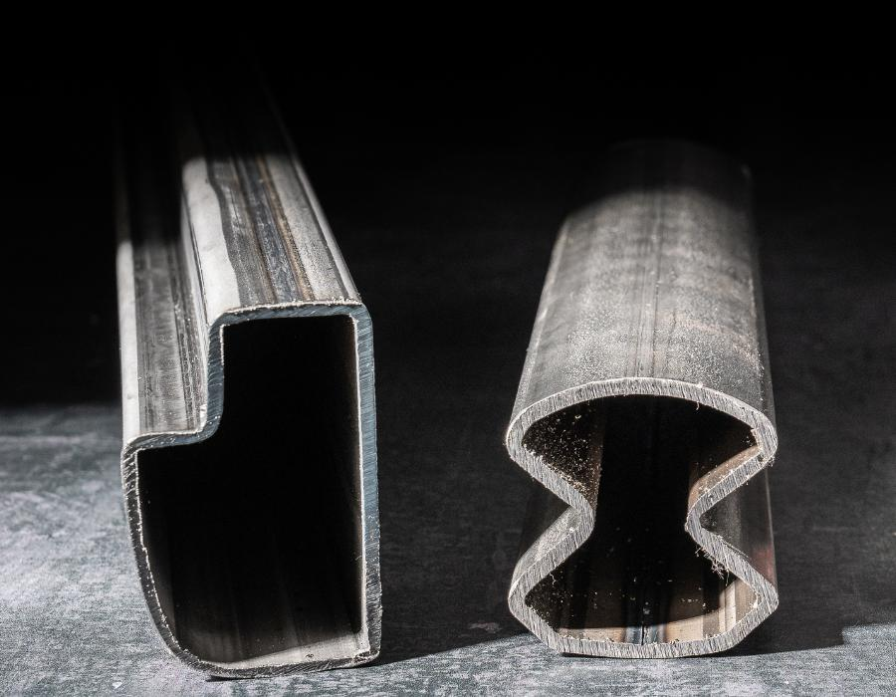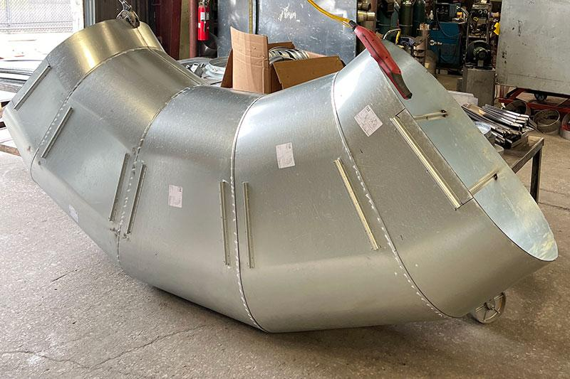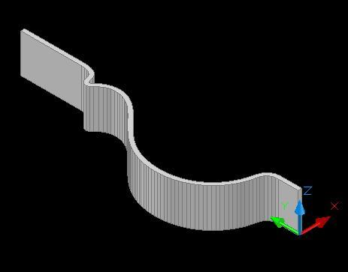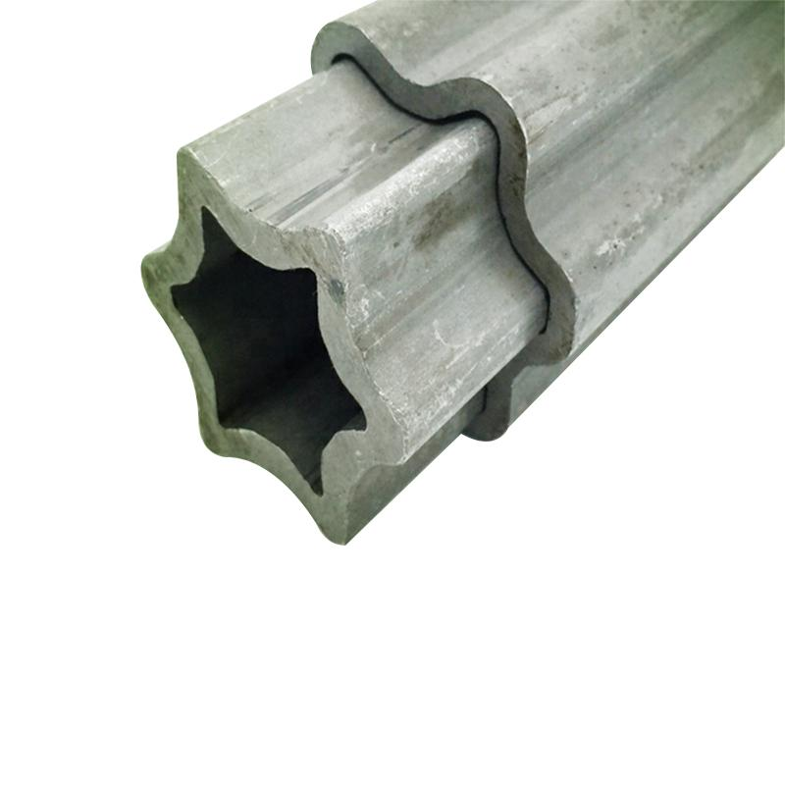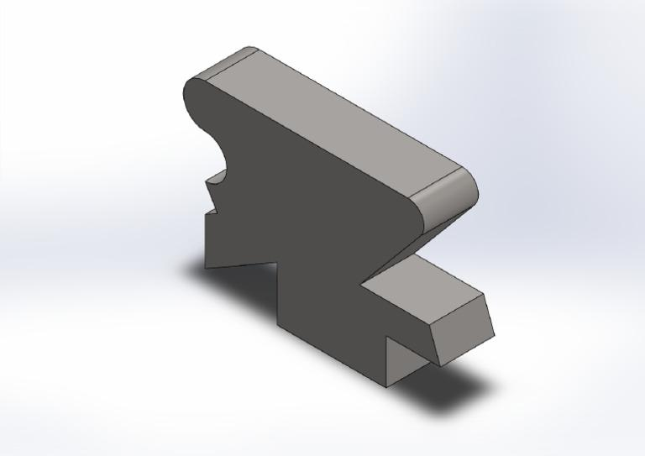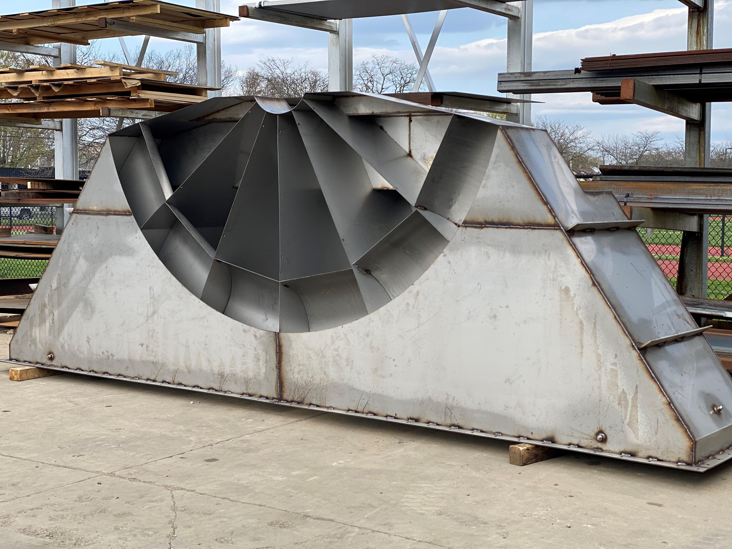
Irregular-region generators are useful in:
- Architecture: Creating custom building profiles, structural components, and complex architectural forms.
- Civil Engineering: Generating irregular structural sections, embankments, and custom construction components.
- Mechanical Engineering: Designing custom mechanical parts and components with non-standard cross-sections.
- Industrial Design: Creating products with unusual profiles and shapes.
- CAD and 3D Modeling: Constructing complex solids through extrusion, revolution, sweeping, and lofting.
- Pipes and Ducts: Generating curved passages with non-standard cross-sections.
These operations are common in computer-aided geometric modeling.

Comparison with Other Plane-Region Generators
# Source: AI Source: Provided by: [Data Path: Persons Table -> ID Column: 1, Name_En Column: Motasem Essam] -> From: [ChatGPT] on [7/25/2026]
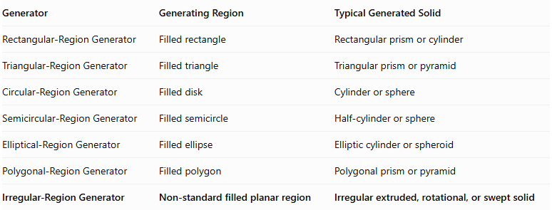
Generator | Generating Region | Typical Generated Solid
Rectangular-Region Generator | Filled rectangle | Rectangular prism or cylinder
Triangular-Region Generator | Filled triangle | Triangular prism or pyramid
Circular-Region Generator | Filled disk | Cylinder or sphere
Semicircular-Region Generator | Filled semicircle | Half-cylinder or sphere
Elliptical-Region Generator | Filled ellipse | Elliptic cylinder or spheroid
Polygonal-Region Generator | Filled polygon | Polygonal prism or pyramid
Irregular-Region Generator | Non-standard filled planar region | Irregular extruded, rotational, or swept solid
Important distinction: An irregular region is a broad category based on the absence of a specific standard boundary shape. It can have straight edges, curved boundaries, or both. It is not limited to irregular polygons.

Main Classification
# Source: AI Source: Provided by: [Data Path: Persons Table -> ID Column: 1, Name_En Column: Motasem Essam] -> From: [ChatGPT] on [7/25/2026]
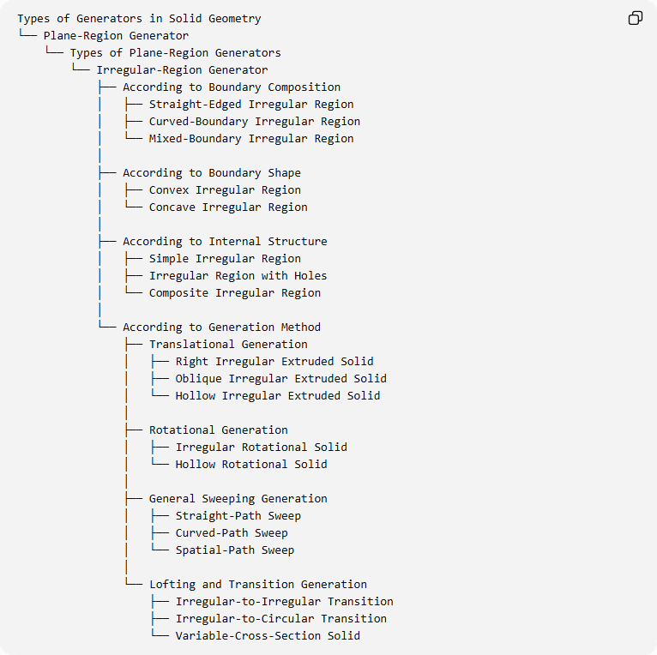
Types of Generators in Solid Geometry
└── Plane-Region Generator
└── Types of Plane-Region Generators
└── Irregular-Region Generator
├── According to Boundary Composition
│ ├── Straight-Edged Irregular Region
│ ├── Curved-Boundary Irregular Region
│ └── Mixed-Boundary Irregular Region
│
├── According to Boundary Shape
│ ├── Convex Irregular Region
│ └── Concave Irregular Region
│
├── According to Internal Structure
│ ├── Simple Irregular Region
│ ├── Irregular Region with Holes
│ └── Composite Irregular Region
│
└── According to Generation Method
├── Translational Generation
│ ├── Right Irregular Extruded Solid
│ ├── Oblique Irregular Extruded Solid
│ └── Hollow Irregular Extruded Solid
│
├── Rotational Generation
│ ├── Irregular Rotational Solid
│ └── Hollow Rotational Solid
│
├── General Sweeping Generation
│ ├── Straight-Path Sweep
│ ├── Curved-Path Sweep
│ └── Spatial-Path Sweep
│
└── Lofting and Transition Generation
├── Irregular-to-Irregular Transition
├── Irregular-to-Circular Transition
└── Variable-Cross-Section Solid

Key Points
# Source: AI Source: Provided by: [Data Path: Persons Table -> ID Column: 1, Name_En Column: Motasem Essam] -> From: [ChatGPT] on [7/25/2026]
- An irregular region is a filled two-dimensional region with a non-standard boundary.
- Its boundary can contain straight segments, curved segments, or both.
- It can be convex, concave, simple, composite, or contain holes.
- Translating it generates an irregular extruded solid.
- Rotating it generates an irregular solid of revolution.
- Sweeping it along a curved or spatial path generates a general swept solid.
- Lofting it with other profiles can generate variable-cross-section solids.
- Its area and volume are calculated using decomposition, integration, or applicable geometric theorems.

Conclusion
# Source: AI Source: Provided by: [Data Path: Persons Table -> ID Column: 1, Name_En Column: Motasem Essam] -> From: [ChatGPT] on [7/25/2026]
The Irregular-Region Generator represents a flexible type of plane-region generator used to create three-dimensional solids from non-standard planar areas. Its importance comes from its ability to generate complex geometries that cannot be adequately represented by conventional generators such as rectangular, triangular, circular, or elliptical regions.

